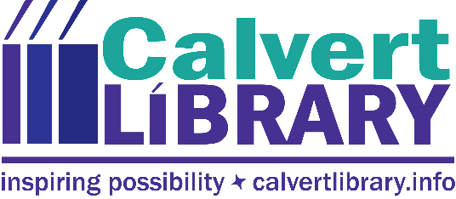

Calvert Library Hosting Political Thriller Author Doug Norton
October 17, 2018
FOR IMMEDIATE RELEASE
Contact: Robyn Truslow
410-535-0291
As a warship captain during the Cold War, Doug Norton held launch codes for nuclear weapons and was prepared to use them. He also participated in international negotiations to reduce their numbers and the chance of nuclear war between the United States and the Soviet Union.

On Monday, November 19, Mr. Norton will visit Calvert Library Prince Frederick at 7pm to present “American Presidents, North Korean Dictators, and the Elephants in the Room,” which relates the fictional plots of his Code Word thrillers to current developments in East Asia.

Mr. Norton’s political thrillers Code Word: Paternity and its sequel Code Word: Pandora feature the stand-off between the United States and North Korea. Drawing on his 25 years of military and diplomatic experience, Doug Norton’s thrillers mix American security, North Korean aggressiveness, and Chinese power in a cauldron of politics, technology, and risk that will keep you up at night, even after you’ve finished reading.

The author has many years of navy and defense department experience including nuclear deterrence, tense White House meetings, and high-stakes diplomacy in Geneva, Brussels, London, and Washington. He brings deep knowledge and authenticity to this presentation ranging from the strategic situation in Korea to the demands and costs of duty and the question of whether evil can be overcome without resorting to evil methods.

The talk will be followed by Q&A and a book signing. Register for the event for a chance to win a copy of your choice.

To register or for more information about this and other upcoming programs, visit calvertlibrary.info or contact Robyn Truslow at 410-535-0291.
###

Related Links
Link to full flyer image

Robyn Truslow
Public Relations Coordinator
Calvert Library
850 Costley Way
Prince Frederick, MD 20678
410-535-0291
410-535-3022 Fax
rtruslow@somd.lib.md.us

