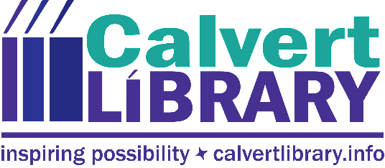

Calvert Library Hosting Viewing and Discussion of Documentary:
In the Executioner’s Shadow: A Story of Justice, Injustice
and the Death Penalty

October 17, 2018
FOR IMMEDIATE RELEASE
Contact: Robyn Truslow
410-535-0291
As the culminating event for a successful 2018 One Maryland One Book celebration, Calvert Library Prince Frederick will host a screening of the new documentary In the Executioner’s Shadow: A Story of Justice, Injustice and the Death Penalty on Tuesday, October 30 at 7pm. Film co-producer and author Rick Stack will be on hand to answer questions and provide in-depth information.
This year’s book is Bloodsworth: The True Story of the First Death Row Inmate Exonerated by DNA Evidence by Tim Junkin. Kirk Bloodsworth was an innocent man on death row in Maryland before the death penalty was abolished here. From the title, it’s clear that he was ultimately freed rather than executed, and his story was instrumental in abolishing Maryland’s capital punishment. However, capital punishment is still part of the justice process in other states, and there are many conflicting opinions about it.
In the Executioner’s Shadow shares three powerful perspectives on the issue—a former state executioner, a Boston Marathon bombing victim, and the parents of a murder victim who chose to fight for the life of their daughter’s killer. The theme of One Maryland One Book this year is “justice.” Participants will talk about what this documentary says about justice and what their own views are. We won’t all agree and we will probably all learn something. The film is under an hour so there will be 30-45 minutes for discussion.
For more information, call Robyn Truslow at 410-535-0291.
###

Related Links
Link to full flyer image

Robyn Truslow
Public Relations Coordinator
Calvert Library
850 Costley Way
Prince Frederick, MD 20678
410-535-0291
410-535-3022 Fax
rtruslow@somd.lib.md.us

