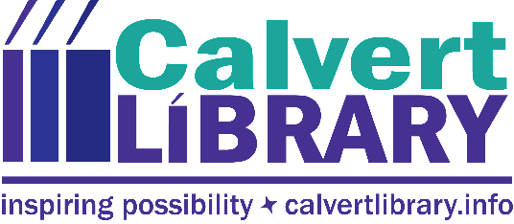

October 17, 2018
FOR IMMEDIATE RELEASE
Contact: Robyn Truslow
410-535-0291
The site selection process for the new Calvert Library Twin Beaches Branch will reopen because North Beach is not able to deliver the land offered in their approved proposal. The offer and acceptance were contingent on North Beach gaining ownership of the 3rd Street property which they would then transfer to the county. To date, no action has been taken nor funds expended in anticipation of the land transfer.
Library Director Carrie Plymire has communicated to both North Beach and Chesapeake Beach that site selection has been reopened. According to Plymire, “The BOLT [Board of Library Trustees] has added a preference for non-contingent offers and we’ve asked for proposals by October 31 in order to keep the process moving and to preserve the option of the state grant. However, I have asked Chesapeake Beach to let me know if they need more time.” BOLT President Martha Grahame noted, “The Twin Beaches area deserves a new library in an accessible location…the sooner the better. But we will not rush the process and risk ending up with a less than ideal location. We want the best possible solution for the community.”
For more information, call Robyn Truslow at 410-535-0291.
###

