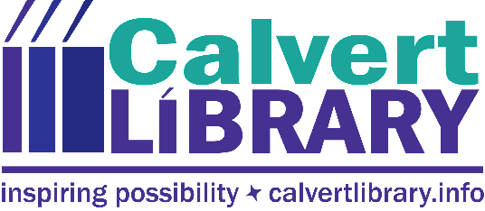

Calvert Library Hosting Thinking Money for Kids Exhibition
November 6, 2019
FOR IMMEDIATE RELEASE
Contact: Robyn Truslow
410-535-0291
Calvert Library Prince Frederick was selected to host Thinking Money for Kids, a traveling exhibition created by the American Library Association (ALA) in partnership with the FINRA Investor Education Foundation.
Thinking Money for Kids is a new multimedia experience for children ages 7 to 11, as well as their parents, caregivers and educators. The interactive exhibit uses games, activities and a fun storyline to help children understand what money is, its function in society, money choices, and money values, such as fairness, responsibility and charitableness. The exhibit will be at Calvert Library Prince Frederick until just before Thanksgiving. The timing is perfectly aligned with Read Across Maryland which also focused on financial literacy this year.
Calvert Library Executive Director Carrie Willson said, “We are delighted to offer Calvert County this catalyst for early parent-child conversations about money. It’s an important topic that can sometimes slip through the cracks of day-to-day life, even though we’re all spending money nearly every day! Kids see a parent tap a phone or swipe some plastic at the grocery store but don’t know what’s really being exchanged. Paychecks are on direct deposit. Bills are paid online after the kids are in bed. People don’t even visit physical banks very often so money has become nearly invisible. This interactive exhibit helps make it concrete.” Calvert County was chosen to host the exhibition through a competitive application process and the library is one of just 50 sites nationwide that will host the exhibit. (Nearly 130 public libraries applied.)
As part of the award, the library received an allowance to host a series of public programs. Calvert Library Prince Frederick Circulation Supervisor Shannon Storm and Public Services Librarian Nathan Summers collaborated to apply for the exhibit and Storm attended a training in Washington, D.C. last summer. Together, Storm and Summers came up with such events as the kickoff that had kids doing educational tasks to “earn dollars” that they could then spend on cookies and lemonade. A Price is Right event was held in late October that helped kids learn to estimate, budget and practice making money decisions. On November 5, kids came to watch and talk about the lessons from the Disney Pixar movie featuring a 78-year-old balloon salesman who ties thousands of balloons to his house to fly UP and away to fulfill a lifelong dream. On Tuesday, November 12, tweens are invited on a Google Expedition with Alexander Hamilton where they will learn about the Father of the US financial system through virtual reality tours and exhibits. All ages are invited to come experience the interactive exhibit until it closes before Thanksgiving.
For more information, call Robyn Truslow at 410-535-0291.
###

Robyn Truslow
Public Relations Coordinator
Calvert Library
850 Costley Way
Prince Frederick, MD 20678
410-535-0291
410-535-3022 Fax
rtruslow@calvertlibrary.info

