Calvert Library Prince Frederick Announces Limited in-Building Service Beginning August 31
August 21, 2020
FOR IMMEDIATE RELEASE
Contact: Robyn Truslow
410-535-0291
Calvert Library Prince Frederick will be opening on Monday, August 31 for limited services. In-person library hours will be Monday-Thursday, noon to 5pm, Friday, 1-5pm and Saturday, 10am to 2pm. Curbside pickup appointments will continue with hours increasing to Monday-Thursday, 10am to 7pm; Friday, 1-5pm and Saturday, 10am to 2pm. Calvert Library’s Branches (Fairview, Twin Beaches and Southern) will be opening with the same hours on Tuesday, September 8.
The main library in Prince Frederick will open with a limit on the number of customers in the building at one time. Per Governor Hogan’s order, customers over the age of five will be required to wear face masks covering their nose and mouth and to maintain a social distance of 6’ from others. Customers entering with children are asked to stay together and help their children maintain social distance. In order to maximize the number of customers who can take advantage of library services, customers will be asked to keep their visit to an hour or less.
According to Executive Director, Carrie Willson, “We’ve been serving customers from home and online since the pandemic closed our buildings. We have even used the outside of our buildings to post community resources and of course, offer wifi in our parking lots. August 31 will be our trial run for in-building service. We expect that our customers and staff will work safely and respectfully together and follow safety guidelines. If that goes smoothly, we will expand limited openings to the branches on Tuesday, September 8.”
Some libraries in the region have been open longer. St. Mary’s County Library opened August 3 and so far, have not had to step back service. Anne Arundel County Library opened some of their locations in early July but announced last week that because of customer incidents and the resulting health concerns, they had to reduce service to the curbside model Calvert Library has been offering since June. Anne Arundel expects to move to an appointment-only model for computer use, browsing and librarian assistance beginning September 8.
When asked whether she’s concerned that customers will try to come to the library without appropriate masks, Willson said, “The two main services we haven’t been able to offer in some form during this pandemic are gathering space and computer use. While it is still not appropriate to be gathering, I believe that the customers who are desperate to use our computers will be self-policing so we don’t have to close our doors again. At the same time, our staff stand ready to remind or educate customers about safe practices. For those that cannot comply, we will continue to serve them outside the building.”
What about computer access? Willson responded, “We have received a grant to purchase some Chromebooks that we plan to circulate with data. Of course, laptops are in great demand in the marketplace so we don’t know when we’ll receive them. We will get them into circulation as quickly as possible once they arrive.”
Calvert Library does not plan to open their meeting rooms for the foreseeable future as those spaces are currently being used for quarantining returned materials and storing furniture not conducive to healthy use of the library. Returned library materials are quarantined for up to a week prior to being checked in based on a recently released study concerning the length of time the virus might survive on library material surfaces.
Ms. Willson reiterated her request, “Please stay home if you are vulnerable or ill. Our staff can help you over the phone. Calvert Library has always prided itself on being the community’s ‘third place,’” referencing a frequented space that is not work or home, “for connecting to one another and the world.” Willson continued, “At this time, for our community’s safety, our priority is to provide quick access to library materials, information and training that can’t be accessed via phone, email or video chat.”
For more information, call Robyn Truslow at 410-535-0291.
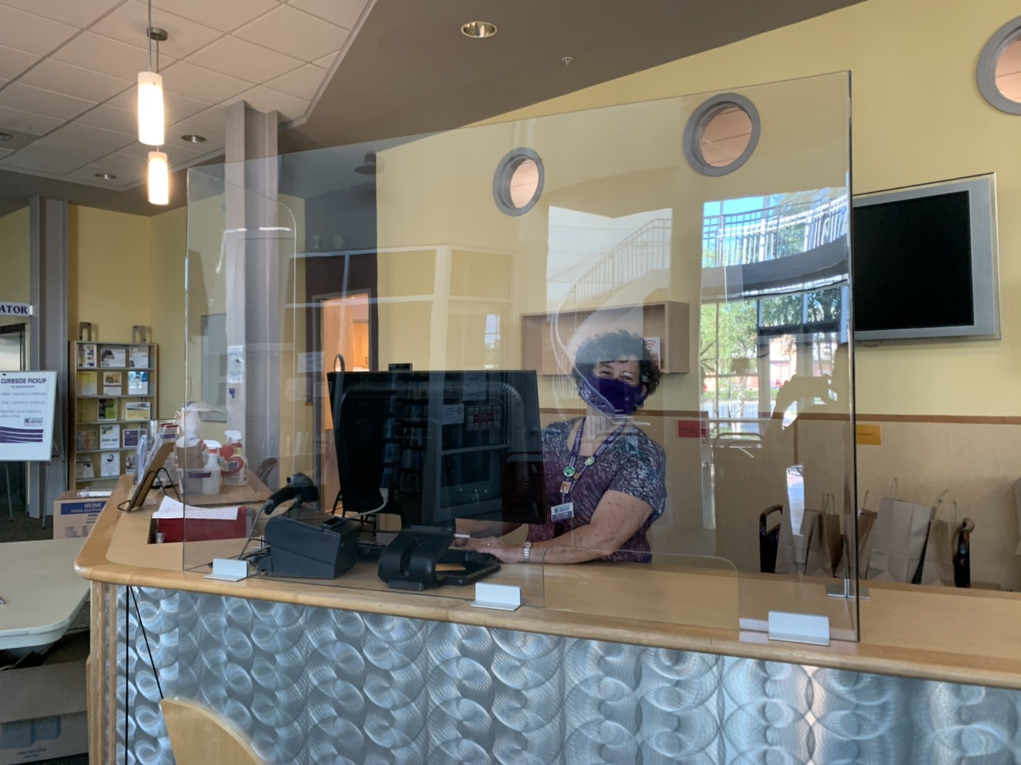
Photo: Plexiglass has been installed on library service desks to improve the safety of customer-staff interactions. Library Assistant Joan Fletcher pulls the Curbside appointments report for the next day at Calvert Library Prince Frederick.
###

Related Links

Robyn Truslow
Public Relations Coordinator
Calvert Library
850 Costley Way
Prince Frederick, MD 20678
410-535-0291
410-535-3022 Fax
rtruslow@calvertlibrary.info

